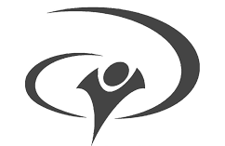
YWAM Kosova
www.ywamkosova.com | office@ywamkosova.com

Taxi Services
List of taxi services in Prishtina.
Taxi Service | Free Call Number | Alternative Phone Number | Viber
Taxi Beki | 0800 111 55 | 044 111 555 | 049 111 555
Taxi Roberti | 0800 111 99 | 044 111 999 | 049 111 999
Urban Taxi | 0800 151 51
City Taxi |  | 044 600 900 | 049 600 900 | ✔
Taxi Dallas | 0800 111 66 | 044 111 666 | ✔
Blue Taxi |  | 044 800 900 | 049 800 900 | ✔

Notes
- Taxi fee starts with 1.5€;
- Taxi from YWAM Kosova to Skenderbeg Square can cost no more than 2.5€;
- Taxi from YWAM Kosova to airport and vice versa can cost no more than 15€;

